When is the public information meeting?

PUBLIC INFORMATION MEETING
Hardwick Memorial Building
20 Church Street
Thursday, February 28, 2019
6:00 p.m.

When is the bond vote?

BOND VOTE – AUSTRALIAN BALLOT
Hardwick Elementary School
135 South Main Street
Tuesday, March 5, 2019
9:00 a.m. to 7:00 p.m.

What improvements are included in the Bridgman Hill Reservoir Roof Replacement?

- Removal and disposal of existing roof structure.
- New permanent roof structure constructed of either steel frame or concrete.
- Tree clearing surrounding Bridgman Hill Reservoir to protect roof.

Why is the Bridgman Hill Reservoir Roof Replacement required?

- The Bridgman Hill Reservoir, constructed in the 1940’s, stores treated water for the Town of Hardwick Water System.
- The Bridgman Hill Reservoir is a critical asset to the water system as it provides adequate storage, in collaboration with the Glenside Storage Tank, for domestic and fire flow demands.
- A Sanitary Survey was performed by the Drinking Water and Groundwater Protection Division in 2012 identifying the existing reservoir roof’s integrity as a minor deficiency.
- The existing “A-frame” wooden sub-structure and metal roof does not provide a tight seal to prevent intrusion from insects or rodents that can degrade water quality.
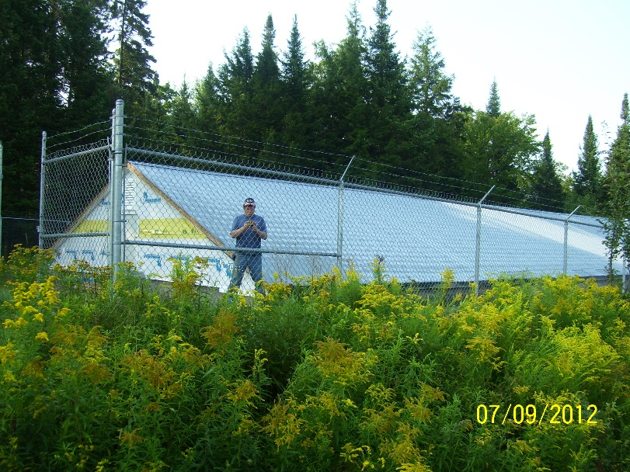

What is the estimated cost and bond amount?

Estimated Construction Cost
Item Description | Estimated Cost
Construction | $300,000
Construction Contingency (10%) | $30,000
Estimated Construction Cost | $330,000

The total project cost is $420,000 and includes: construction costs, 10% construction contingency, engineering, and other related project costs.

The recommended bond amount is $420,000

What are the available funding sources?

Funding is through the State of Vermont Drinking Water SRF Program is anticipated for a 30-year term at a rate of 0%, with a 40% disadvantaged subsidy. Based on this information, the annual loan payment to the State of Vermont, for a $252,000 loan amount is approximately $8,435.

As of July 1, 2019, the Town will have reserved $129,000 through the capital fund specifically for the Bridgman Hill Reservoir Roof Replacement. These reserve funds will be applied as principal to the DWSRF loan.

What is the projected impact on the current Water Rates?

A typical Town residential water customer pays a base rate of $71.25 per unit per quarter, which includes 10,000 gallons of allotted water. All water usage over the allotted base amount is charged at $0.005 per gallon.

A typical residential customer is anticipated to see their base rate increase by approximately $1.50 per quarter. The debt retirement for the Bridgman Hill Reservoir Roof Replacement will be paid by the water system customers only.

What is the project schedule?

Projected Date |  | Task
2019 | March 5 | Conduct Bond Vote
 | March | Start Preliminary Engineering
 | May | Finalize Preliminary Engineering  Start Final Design
 | July | Complete Final Design
 |  | Advertise for Bids
 | August | Contract Award
 | September | Start Construction
 | December | Complete Construction
2020 | December | End of 1-Year Warranty Period

