Pollinator-Friendly Solar Resources
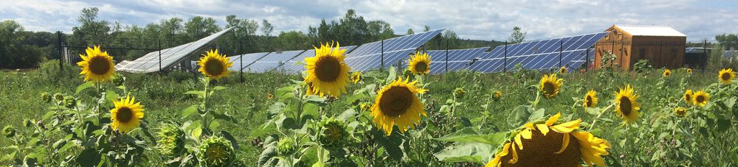
Land under and around solar arrays can be planted with pollinator-friendly vegetation: a benefit to agriculture, clean energy, bees and birds.
To achieve this, many solar projects are now integrating a vegetative management plan that features a mix of low-growing and shade tolerant, pollinator friendly plants throughout the array.

Pollinator-Friendly Planting Tips
Considering installing solar at your farm, home or business and want to be sure it's friendly to pollinators? Here's how to get started:
- Step 1: Contact a pollinator vegetation expert (see list below)
- Step 2: Make sure consultants use the VT Scorecard in their planning and budget to ensure that the site can be considered pollinator-friendly
- Step 3: Work with Vermont Suppliers for Native Plants and Seeds (PDF) to source pollinator-friendly seed mixes as well as shrubs and trees for screening around solar arrays. Refer to the following lists to identify appropriate species for your project: Vermont Bird and Pollinator-Friendly Perennials (PDF) and Vermont Bird and Pollinator-Friendly Shrubs (PDF).
- Step 4: Consider building in an annual assessment plan like this Sample Pollinator Survey Tool (PDF)
- Step 5: Once you’ve finished your pollinator seeding/plantings, send your completed scorecard to info@revermont.org, and post it on your own website to say you’ve joined the Pollinator-Friendly Solar Initiative!
- Step 6: We encourage you to share your vegetative management plans as resource materials for others on this website. Please send them to extweb@uvm.edu and we will share them below.
More Resources:
- Plants for Bird-Friendly plants for your Solar Screening (Audubon)

